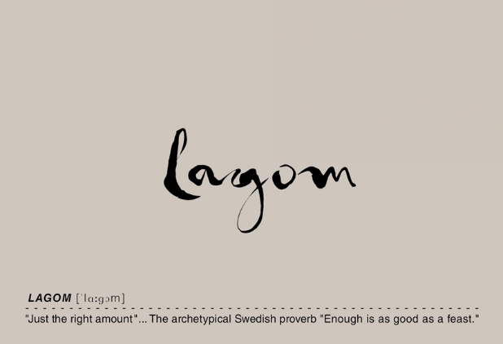
2023 TORRIN “LAGOM” CHARDONNAY
Varietals: 100% Chardonnay
Vineyards: Spanish Springs
Appellation: San Luis Obispo Coast
Fermentation: Native Yeast, 100% ML
Barrel: 11 months, 300L French Oak, 50% New French Oak-50% Once used French oak.

Alcohol %: 14.2
Production: 220 Cases

Winemaking
Spanish Springs Vineyard located just east of Pismo Beach in the SLO Coast AVA is an incredible place to grow Chardonnay. The 2023 vintage is our ninth bottling from this site and once again the wine is beautifully textured and aromatically complex. With vibrant acidity supporting the substantial palate presence, the finish is bright and fresh. After a light pressing, the juice is transferred to a mix of new and once used 300L French Oak barrels. The fermentation takes place over the following 2 plus months utilizing only native yeast. This long slow fermentation keeps the lees in suspension, contributing to the rich textural presence of the wine. After completion of the malo-lactic fermentation and barrel aging of roughly 12 months, the wine is racked to tank prior bottling unfined and unfiltered. We then age the wine for an additional 2 years in bottle prior to release. This allows subtle mineral tones of flint, oyster shells and saline notes to mingle with the tropical fruit, citrus and hints of chamomile and bee’s wax. Enjoy the 2023 Chardonnay now or as it gracefully evolves over the next 7-10 years.

Release Date – Fall -2026
Drinking Window – Now – 2034

